Que1) Write the algorithm for push and pop operation.

Ans1)

**Push Operation Algorithm**

1. Check for Overflow: (top == MAX - 1), display an error message and exit.
2. Input an Item.
3. Increment the Top: top++
4. Insert the Element: Assign the new element to stack[top].
5. Exit

**Pop Operation Algorithm**

1. Check for Underflow: (top == -1), display an error message and exit.
2. Retrieve the Element: Store the value of stack[top] in a temporary variable.
3. Decrement the Top: top--
4. Return the Popped Value: Return the value stored in the temporary variable.
5. Exit

Que2) Write a C program for push pop and display the stack elements using function.

Ans2)

#include <stdio.h>

#include <stdbool.h>

#define MAX 1000

int stack[MAX];

int top = -1;

bool push(int value) {

    if (top == MAX - 1) {

        printf("Stack overflow\n");

        return false;

    }

    stack[++top] = value;

    return true;

}

int pop() {

    if (top == -1) {

        printf("Stack underflow\n");

        return -1;

    }

    return stack[top--];

}

void display() {

    if (top == -1) {

        printf("Stack is empty\n");

        return;

    }

    printf("Stack elements: ");

    printf("{");

    for (int i = top; i >= 0; i--) {

        printf("%d ", stack[i]);

    }

    printf("}\n");

}

void main() {

    printf("SHIV ARORA\n");

    int choice, value;

    while (true) {

        printf("\nChoose an operation:\n");

        printf("1. Push\t2. Pop\t3. Display  4. Exit\n");

        printf("Enter your choice: ");

        scanf("%d", &choice);

        switch (choice) {

            case 1:

                scanf("%d", &value);

                push(value);

                break;

            case 2:

                value = pop();

                if (value != -1) {

                    printf("Popped: %d\n", value);

                }

                break;

            case 3:

                display();

                break;

            case 4:

                return 0;

            default:

                printf("Invalid choice. Please try again.\n");

                break;

        }

    }

}

OUTPUT:

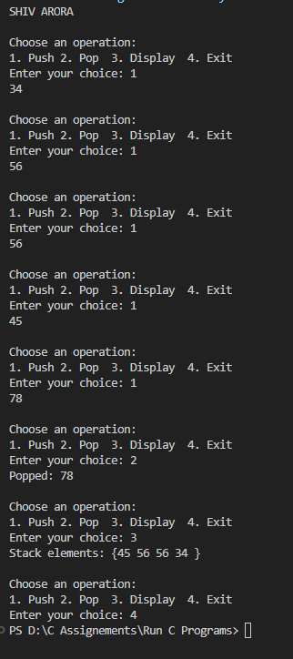

Que3) Write a program to show the ADT of stack using structure in C.

Ans3)

#include <stdio.h>

#include <stdlib.h>

#include <stdbool.h>

#define MAX 1000

typedef struct Stack {

    int arr[MAX];

    int top;

} Stack;

void initStack(Stack* stack) {

    stack->top = -1;

}

bool push(Stack* stack, int value) {

    if (stack->top == MAX - 1) {

        printf("Stack overflow\n");

        return false;

    }

    stack->arr[++stack->top] = value;

    return true;

}

int pop(Stack* stack) {

    if (stack->top == -1) {

        printf("Stack underflow\n");

        return -1;

    }

    return stack->arr[stack->top--];

}

void display(Stack* stack) {

    if (stack->top == -1) {

        printf("Stack is empty\n");

        return;

    }

    printf("{ ");

    for (int i = stack->top; i >= 0; i--) {

        printf("%d ", stack->arr[i]);

    }

    printf("}\n");

}

int main() {

    printf("SHIV ARORA");

    Stack stack;

    initStack(&stack);

    int choice, value;

    while (true) {

        printf("\nChoose an operation:\n");

        printf("1. Push\t2. Pop\t3. Display\t4. Exit\n");

        printf("Enter your choice: ");

        scanf("%d", &choice);

        switch (choice) {

            case 1:

                printf("Enter value to push: ");

                scanf("%d", &value);

                push(&stack, value);

                break;

            case 2:

                value = pop(&stack);

                if (value != -1) {

                    printf("Popped: %d\n", value);

                }

                break;

            case 3:

                display(&stack);

                break;

            case 4:

                return 0;

            default:

                printf("Invalid choice. Please try again.\n");

                break;

        }

    }

    return 0;

}

OUTPUT:

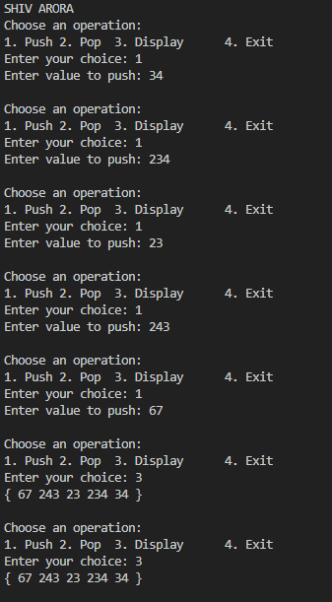

Que4) Write a program to reverse string using stack.

Ans4)

#include <stdio.h>

#include <string.h>

#define MAX 100

typedef struct Stack {

    char arr[MAX];

    int top;

    } Stack;

void initStack(Stack* s) {s->top = -1;}

int isFull(Stack* s) {return s->top == MAX - 1;}

int isEmpty(Stack* s) {return s->top == -1;}

void push(Stack* s, char ch) {

    if (!isFull(s)) s->arr[++s->top] = ch;

    }

char pop(Stack* s) {

    return !isEmpty(s) ? s->arr[s->top--] : '\0';

    }

void reverseString(char* str) {

    Stack s; initStack(&s);

    for (int i = 0; str[i]; i++) push(&s, str[i]);

    for (int i = 0; str[i]; i++) str[i] = pop(&s);

}

int main() {

    printf("SHIV ARORA\n");

    char str[MAX];

    printf("Enter a string: ");

    fgets(str, MAX, stdin);

    str[strcspn(str, "\n")] = 0;

    reverseString(str);

    printf("%s\n", str);

    return 0;

}

OUTPUT:

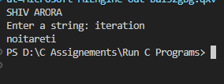

Que5) Write a program to convert infix into postfix using stack.

Ans5)

#include <stdio.h>

#include <stdlib.h>

#include <ctype.h>

#include <string.h>

#define MAX 1000

typedef struct Stack {char arr[MAX]; int top;} Stack;

void push(Stack* s, char ch) {s->arr[++s->top] = ch;}

char pop(Stack* s) {return s->top == -1 ? '\0' : s->arr[s->top--];}

char peek(Stack* s) {return s->top == -1 ? '\0' : s->arr[s->top];}

int precedence(char op) {return op == '+' || op == '-' ? 1 : op == '*' || op == '/' ? 2 : 0;}

int main() {

    printf("SHIV ARORA\n");

    Stack s; s.top = -1;

    char infix[MAX], postfix[MAX];

    printf("Enter infix: ");

    fgets(infix, MAX, stdin);

    int j = 0;

    for (int i = 0; infix[i]; i++) {

        if (isalnum(infix[i])) postfix[j++] = infix[i];

        else if (infix[i] == '(') push(&s, infix[i]);

        else if (infix[i] == ')') {

            while (peek(&s) != '(') postfix[j++] = pop(&s);

            pop(&s);

        } else {

            while (s.top != -1 && precedence(peek(&s)) >= precedence(infix[i]))

                postfix[j++] = pop(&s);

            push(&s, infix[i]);

        }

    }

    while (s.top != -1) postfix[j++] = pop(&s);

    postfix[j] = '\0';

    printf("Postfix:  %s\n", postfix);

    return 0;

}

OUTPUT:

